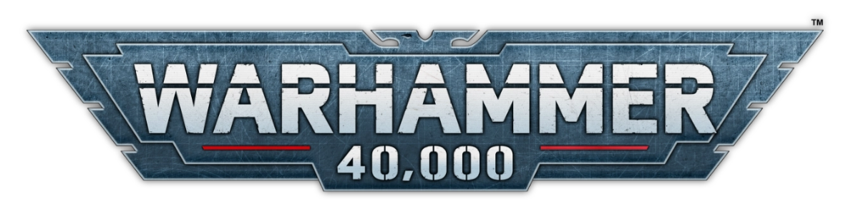

**CRUSADE**

MISSION PACK

The Forsarr War: Cold Reign

# Introduction

A Forsarr War campaign brings together multiple players to forge uneasy alliances and wage a series of linked battles across the ravaged Forsarr Sub‑Sector. It unfolds over three escalating phases, each comprising numerous engagements between the competing factions. At the conclusion of each phase, the alliance with the most Campaign Points claims victory in that phase and is awarded Strategic Points, which roll over toward the campaign’s ultimate outcome. Because each successive phase is worth more Strategic Points than the last, no alliance can rest on early successes alone—victory will be decided only when the final echoes of war have died away.

Throughout a Cold Reign campaign, every player’s Crusade force will harvest Kelthorian Filaments, the warp‑scarred strands of the Sensory Nexus that fell into Forsarr’s ruins. At the end of each campaign phase, allied players may pool their Filaments to purchase powerful bonuses or convert them into Strategic Points for their alliance’s cause. While each commander is responsible for managing their own Filament tally, the choices they make about sharing—or hoarding—this precious resource can tip the balance between triumph and oblivion.

# Campaign Arbiter

Every Forsarr War narrative benefits from a dedicated Campaign Arbiter. This role oversees scheduling, match‑making and tracking alliance progress, so that the other players can focus on the heat of battle. The Arbiter may also take the field with their own Crusade force, but their primary duty is to facilitate a smooth, epic campaign experience.

## Forming Alliances

Once an Arbiter is in place, their first task is to gather players and assign them to alliances. Forsarr War thrives with anywhere from 4 up to dozens of participants, though it works best with a tight‑knit group who can meet regularly. Aim to balance alliance sizes and—where possible—align players by their chosen armies.

After assignment, each player’s Crusade force is bound to that alliance for the full campaign. Faction changes mid‑campaign are discouraged but may be permitted at the Arbiter’s discretion.

The suggested alliances for the Forsarr War are:

* **The Iron Bastion**

Defenders of the Imperium: Cadian regiments of the 368th and 426th, the Garnet Swans, and loyalist elements of Cohort Omnis‑9. United by duty, these defenders seek to reclaim Druscar’s Ruin and purge the darkness from Kelthorn II.

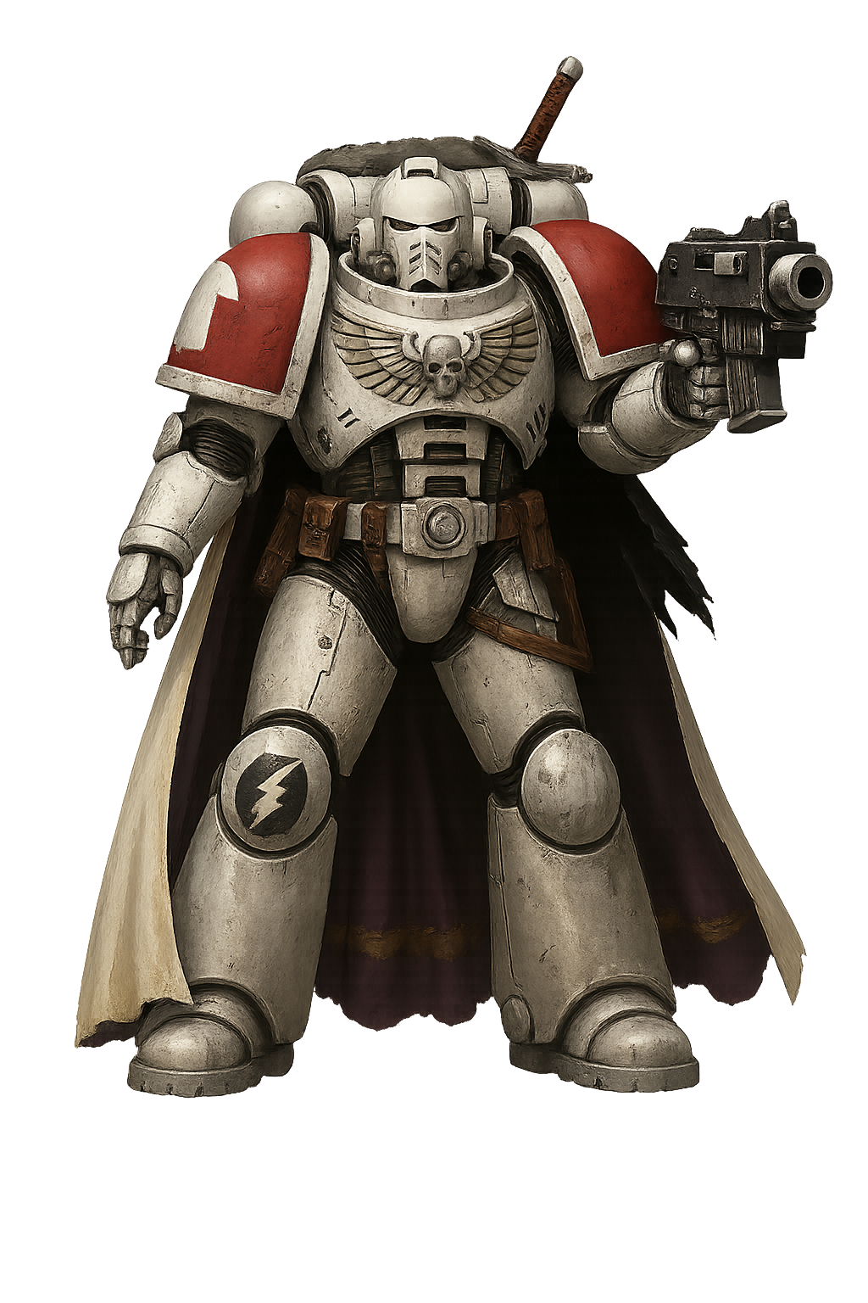

* **The Dark Forge**

Heretics of the Mechanicus and Chaos: Archmagos Diabolus’s Dark Mechanicum forges, the Destroyer Hive Plague Company of the Death Guard, and daemonic hosts of Slaanesh and Nurgle. They strive to spread contagion and corruption, forging a new order of metal and malice.

* **The Savage Swarm**

Xenos predators and warbands: remnants of Bogggoff’s Goff Goggaz, Ork scrap‑lords vying for dominance, and broods of Hive Fleet Leviathan. United only by hunger and WAAAGH!, they tear at the Imperium’s flank in brutal, unpredictable assaults.

## Allies of Convenience

These categories are guidelines, not strict rules. If your group’s roster demands a different structure—or if an unconventional coalition makes for a richer story—the Arbiter should feel free to improvise. Perhaps a rogue Aeldari sept fights alongside the Iron Bastion, or mercenary Tech‑Priests join the Savage Swarm for their own gains—forge your alliances as your saga demands.